**OD matrix estimation using traffic counts**

**Problem statement:**

There are two situations related to O-D demand and flow count. The first one is traffic assignment, which aims to calculate link flows starting from O-D flows, network, and path choice model. Vice-versa, the second one is OD matrix estimation, which is to calculate the O-D flows starting from the measured link flows, using network and path choice model (see Fig. 1).

This document covers the methods aiming to describe the estimations of present origin-destination demand flows by combining direct and/or indirect (model) estimators with other aggregate information related to O-D demand flows. The problem of estimating O-D flows by using traffic counts can be considered as the inverse assignment problem. The example is shown in Fig. 2 and it has 9 nodes, 10 links, and 2 OD pairs (1-3, 2-3).

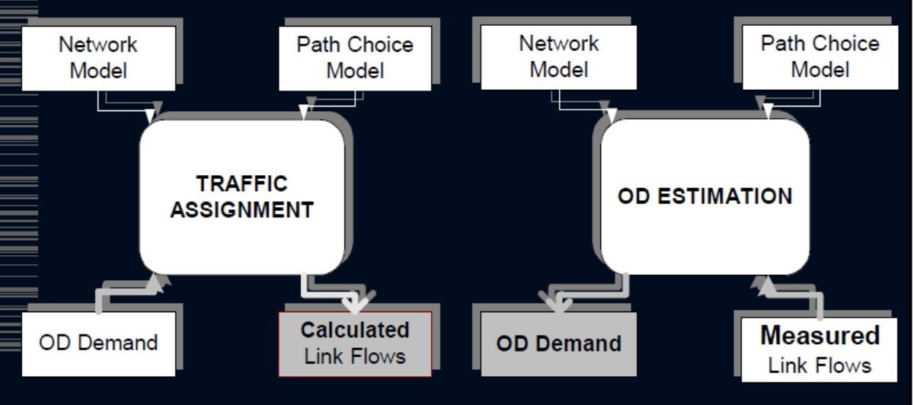

**Figure 1 Relationship between the estimation of O-D flows with traffic counts and**

**traffic assignment**

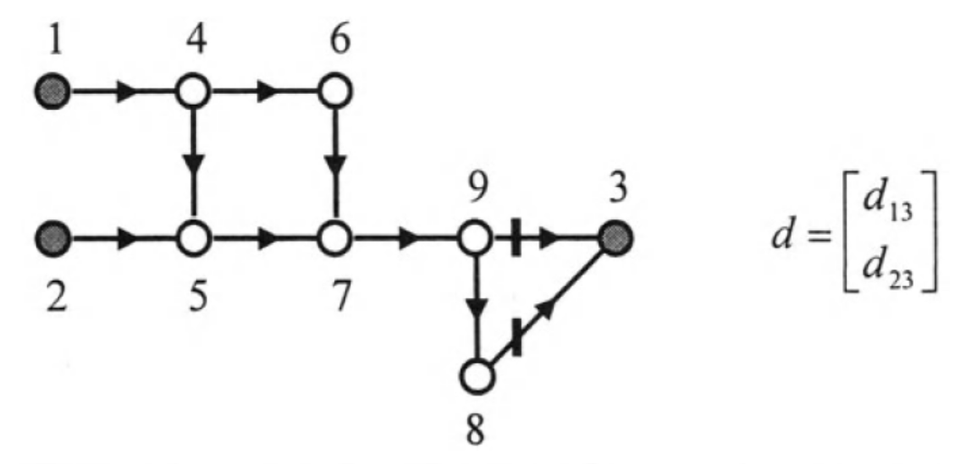

**Figure 2 Network structure**

**Notations:**

$M\left(o,d,i,j\right)$: OD pair $(o,d)$ to link $(i,j)$ proportion

$P\left(o,d,k\right)$: OD pair $(o,d)$ to path $k$ proportion

$D(o,d)$: demand of OD pair $(o,d)$

$f(i,j)$: observed flow counts of link $(i,j)$

$δ(k,i,j)$: link-path incidence matrix, if link $(i,j)$ is on the path $k$, $δ(k,i,j)=1$, otherwise, $δ(k,i,j)=0$

**Equations:**

|  |  |
| --- | --- |
| $$M\left(o,d,i,j\right)=\sum_{o,d}{\sum_{k}{\sum_{i,j}{P\left(o,d,k\right)*δ\left(k,i,j\right)}}}$$ | (1) |
| $$minz=\sum_{i,j}{{\left[\sum_{o,d}{M\left(o,d,i,j\right)*D(o,d)-f(i,j)}\right]}^{2}}$$ | (2) |
| $$D(o,d)≥0$$ | (3) |

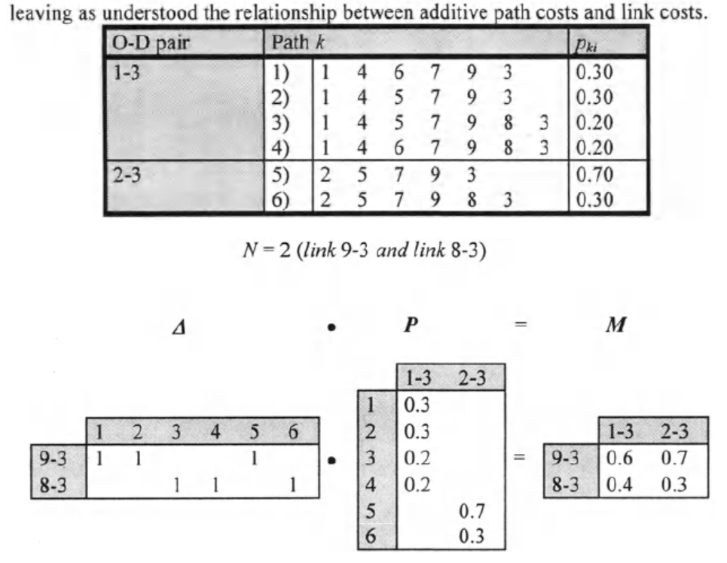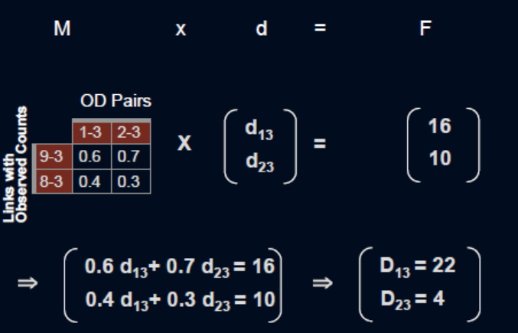

**Figure 3 Analysis by mathematical calculation**

**Analysis by GAMS code:**

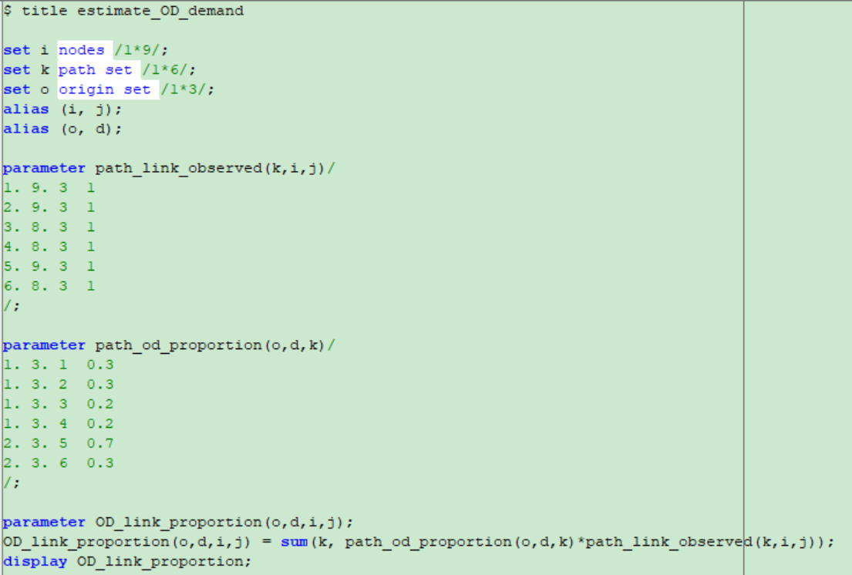

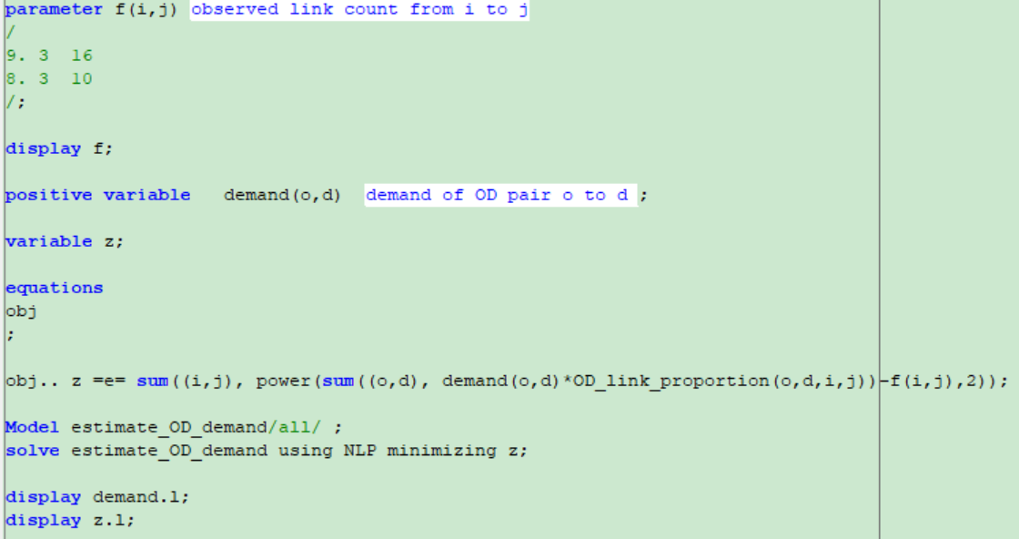

**Results:**

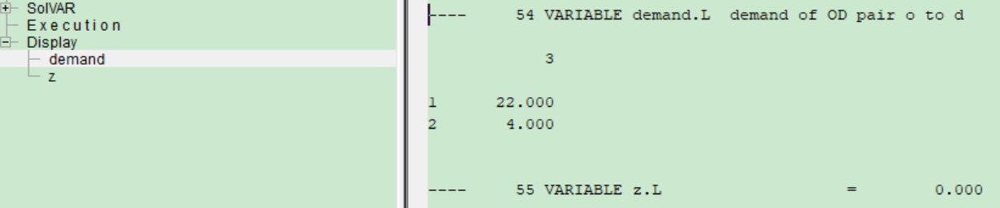

***Reference:*** *Cascetta, E. (2013). Transportation systems engineering: theory and methods (Vol. 49). Springer Science & Business Media.*